

MSE800 Professional Software Engineering
Assessment1: Object Oriented Programming
Car Rental System Report

Student Id: 270931971
Student Name: Pei Wu
Date: 9/9/2026

Table of Content
1. Introduction 3
2. Application Overview 3
3. Design and Architecture 4
3.1. Architectural Diagram 4
3.2. Entity Relationship Diagram 5
3.3. Use Case Diagram 7
3.4. Activity Diagram 8
3.5. Class Diagram 12
3.6. Sequence Diagrams 13
4. Object-Oriented Principles and Design Patterns 17
4.1. SOLID Principles in the Codebase 17
4.2. Factory Method Pattern 17
4.3. Observer Pattern 18
4.4. Layered Architecture 18
5. Innovative Solution 19
5.1. Proposed Innovation 19
5.2. Industry Problem Addressed 19
5.3. Competitive Advantage 19
5.4. Coding Standards 20
6. Software Evolution 20
6.1. Maintenance Strategy 20
6.2. Versioning Strategy 21
6.3. Backward Compatibility Strategy 21
6.4. Future Roadmap 21
7. Conclusion 22
8. References 22

Introduction
This report documents the design, implementation, and evolution plan for a Car Rental System. This system automates the management of the traditional paper-based processes of the car rental company by using an object-oriented Python architecture, with SQLite as the persistence layer.
The report is organised around the assignment's three tasks: Section 3 and 4 address Task 1 (Design and Architecture) by presenting the system's UML diagrams and the object-oriented principles and design patterns applied; Section 5 addresses Task 2 (Innovative Solutions) by describing a feature that differentiates the system from a traditional car rental workflow; and Section 6 addresses Task 3 (Software Evolution) by setting out how the system would be maintained, versioned, and kept backward compatible over time.

Application Overview
This system is a Command-line Interface application, divided into two types of roles: customer and admin, each with specific privileges. The underlying layer is supported by three SQLite database tables (users, cars, bookings).
The table below shows the mapping relationship between the assignment's requirements and the implementation modules corresponding to the system's functions.
Requirement | How It Is Met
(a) User registration and login | User.register() and User.authenticate() in models.py.
(b) Differentiated customer/admin roles with specific privileges | The admin class and the customer class are two derived subclasses of the abstract user class. The specific operations unique to the roles are defined only in the methods of the corresponding subclasses.
(c) Car database with ID, make, model, year, mileage, availability, min/max rent period | The cars table and the Car class, which expose every one of these fields.
(d) Admins can add, update, and delete car records | In the admin class of models.py, Admin.add_car() / Admin.update_car() / Admin.delete_car().
(e) Customers can view available cars and their details | In the customer class of models.py, Customer.view_available_cars(), backed by Car.list_all(only_available=True).
(f) Booking feature: select a car, specify rental dates, provide details | In the customer class of models.py, Customer.book_car(car, start_date, end_date, notes), which validates the date range against the car's availability before creating a booking.
(g) Calculate rental fees from car, duration, and additional charges | In the car class of models.py, Car.calculate_fee(), which validates the requested dates (rejecting a start date in the past, and enforcing the car's min/max rental period) before computing daily_rate × duration plus a mileage-based surcharge for high-mileage vehicles.
(h) Admins can approve or reject booking requests | In the admin class of models.py, Admin.approve_booking() / Admin.reject_booking(), which delegate to Booking's own state-transition methods.
Beyond these basic requirements, the system includes an active reservation notification function based on the Observer design pattern (see Section 4.3), which is an innovative solution proposed for this project.

Design and Architecture
This section will employ architectural diagrams and UML diagrams, including entity-relationship diagrams, use case diagrams, activity diagrams, class diagrams, and sequence diagrams, to elaborate and present the overall design plan of the system.

Architectural Diagram
This system is implemented based on a three-layer architecture. The presentation layer (main.py) is specifically responsible for handling user interaction logic. The domain layer (models.py) holds all business rules and integrates the two design patterns discussed in Section 4. The persistence layer (db.py) provides lightweight SQLite data access capabilities. The arrows indicate the dependency flow direction, and each layer can only call the directly lower layer, prohibiting reverse calls.
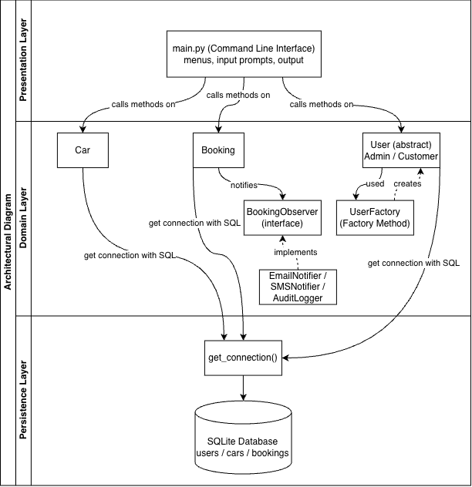
Figure 1 - High-Level Architectural Diagram
- Presentation Layer (main.py): prints menus, reads input, displays output, and calls methods on domain objects. It contains no business logic of its own.
- Domain Layer (models.py): the User/Admin/Customer hierarchy, Car, Booking, and the two pattern classes UserFactory and BookingObserver (with its concrete notifiers). All validation and calculation rules live here.
- Persistence Layer (db.py): a single get_connection() helper and the schema definition; every domain class goes through this helper rather than opening its own database connection.

Entity Relationship Diagram
The system stores data in three SQLite tables: users, cars, and bookings. The ER diagram below shows each table's fields, primary keys (key icon), foreign keys (link icon), and the relationships between tables.
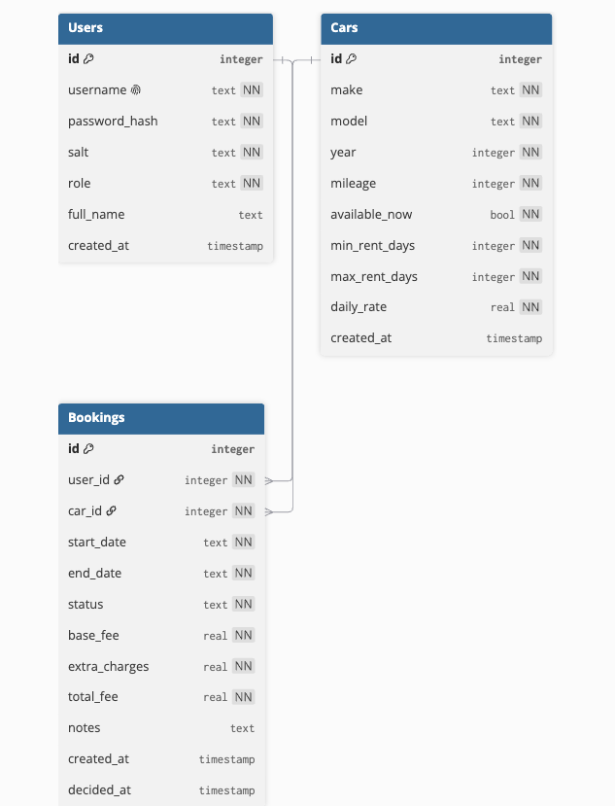
Figure 2 - Entity Relationship Diagram

Users table
Field | Type | Description
id | integer (PK) | Auto-incrementing primary key.
username | text, unique, not null | Login identifier, which must be uniquely enforced at the database level.
password_hash | text, not null | Hash of the password.
salt | text, not null | Random per-user salt used when hashing the password.
role | text, not null | Either 'admin' or 'customer', determines which subclass is built at runtime.
full_name | text, nullable | Optional display name; not required at registration.
created_at | timestamp | Defaults to the current time when the row is inserted.

Cars table
Field | Type | Description
id | integer (PK) | Auto-incrementing primary key.
make | text, not null | The manufacturer of the vehicle.
year | integer, not null | Year the vehicle was manufactured.
mileage | integer, not null | Current odometer reading, used to calculate the fee.
available_now | bool, not null | Whether the car can currently be booked.
min_rent_days / max_rent_days | integer, not null | Bounds on how many days a single booking may span.
daily_rate | real, not null | Base rental price per day, used in fee calculation.
created_at | timestamp | Row creation time.

Bookings table
Field | Type | Description
id | integer (PK) | Auto-incrementing primary key.
user_id | integer (FK -> users.id) | The customer who placed the booking.
car_id | integer (FK -> cars.id) | The car being booked.
start_date / end_date | text, not null | Used to calculate the rental period, in storage format as YYYY-MM-DD.
status | text, not null | Status of booking, one of pending, approved, rejected, cancelled, completed.
base_fee / extra_charges / total_fee | real, not null | Fee breakdown produced by the fee calculation.
notes | text, nullable | Free-text notes the customer can attach to a booking.
created_at | timestamp | When the booking request was submitted.
decided_at | timestamp, nullable | When an Admin approved or rejected the booking. NULL while still pending.

- The relationship between users and bookings is one to many: a customer may place multiple bookings while a booking belongs to exactly one user.
- The relationship between cars and bookings is one to many: a car may appear in multiple bookings in different date ranges while a booking references exactly one car.

Use Case Diagram
The Use Case Diagram describe the behaviour of the system from the perspectives of two system roles, without involving internal implementation details.
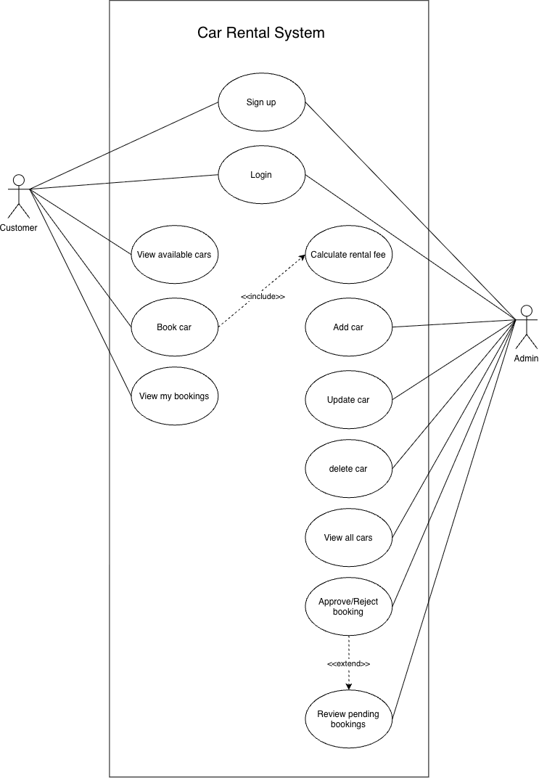
Figure 3 - Use Case Diagram

Roles
- Customer, an end user who registers, logs in, views cars, and places/tracks bookings.
- Admin, a staff member who manages the fleet and approves or rejects booking requests.

Use cases
Use Case | Actor(s) | Description
Sign up | Customer, Admin | Create a new account with a chosen role.
Login | Customer, Admin | Authenticate and reach the role-specific menu.
View available cars | Customer | Browse the list of cars currently marked available.
Book car | Customer | Select a car and date range and submit a rental request.
View my bookings | Customer | See the status and fee details of past and current bookings.
Add / Update / Delete car | Admin | Maintain the fleet's records.
View all cars | Admin | See the full fleet regardless of availability.
Review pending bookings | Admin | Open the queue of bookings awaiting a decision.
Approve/Reject booking | Admin | Decide the outcome of a pending booking.

Include and extend relationships
- Book car «include» Calculate rental fee: fee calculation always occurs as part of booking. it is not something the Customer triggers separately.
- Approve/Reject booking «extend» Review pending bookings: approving or rejecting is an optional continuation of reviewing the pending list, which can also be done on its own (e.g., just to look, without deciding).

Activity Diagram
The Activity Diagrams use swimlanes to present each workflow step by step. Each lane corresponds to a responsible party: the customer, the system, and the admin. The diamond symbols show the decision points. The system swimlane represents the logic executed by the system itself, such as validation, database access, calculations, which are not operations performed by humans.

Registration
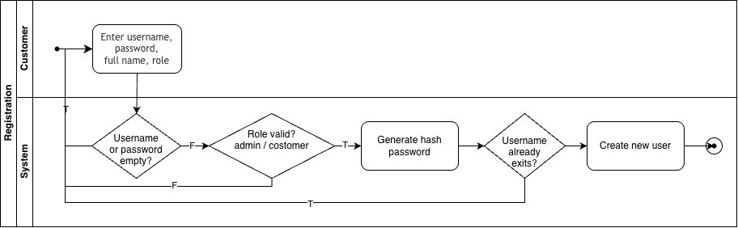
Figure 4 - Activity Diagram: Registration
The Customer submits their detailed informations, then the System lane performs every subsequent check before creating the account, looping back to re-prompt the Customer whenever a check fails.

Login
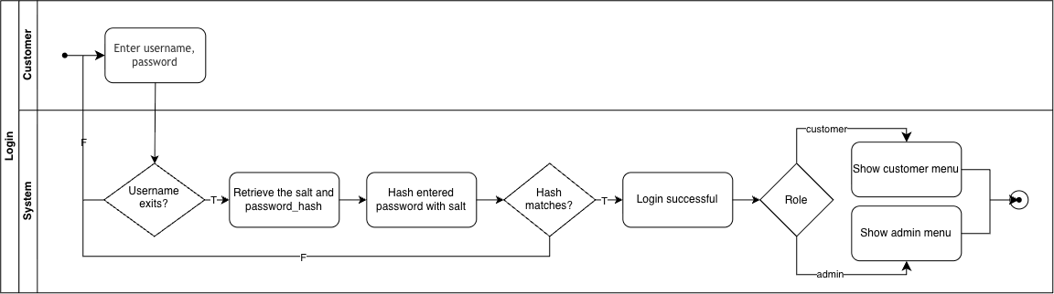
Figure 5 - Activity Diagram: Login
After the system verifies the username and password hash, it follows the branch process based on the account's role and eventually enters the customer menu or the administrator menu. This role division model is consistent with the inheritance relationship of users, administrators, customers in the class diagram.

View Available Cars / My Bookings
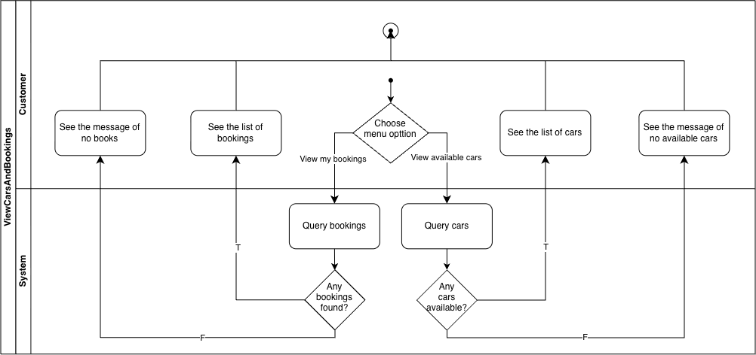
Figure 6 - Activity Diagram: View Available Cars and My Bookings
The two processes share this diagram because they follow the same structure: the customer selects the list to view, the system queries the corresponding table, and the customer then sees the results or a "not found" message.

Admin Car Management
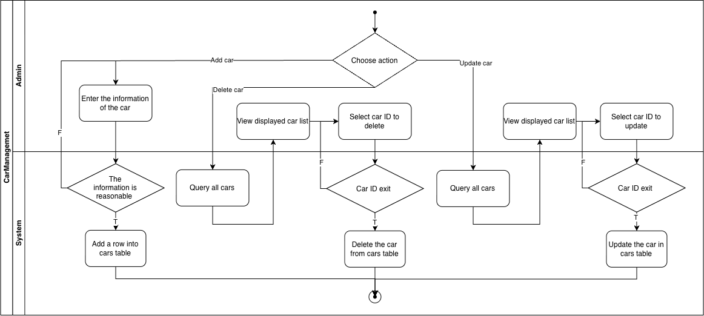
Figure 7 - Activity Diagram: Admin Car Management
The three fleet maintenance operations (addition, update, deletion) are displayed side by side, as they follow the same overall pattern: the administrator provides the input, the system verifies it, and only after the verification is successful will the vehicle table be modified; otherwise, the administrator will be prompted again.

Booking Creation and Approval
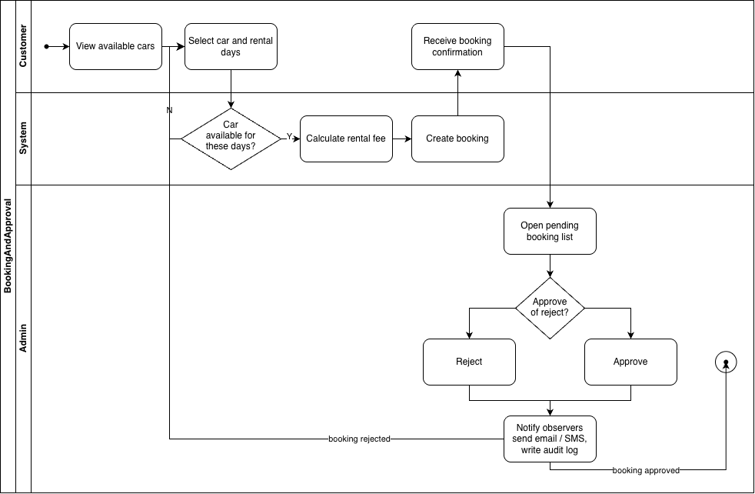
Figure 8 - Activity Diagram: Booking Creation and Approval
This is the most complex workflow, and it corresponds exactly to the steps shown in the Sequence Diagram in Section 3.6.
Two points are worth highlighting:
- The "No" (N) branch in the availability check step loops back directly to the vehicle/date selection step. If the customer's selected date is unavailable, the process does not terminate. Instead, it allows the customer to try again.
- The "Notify observers" action is located in the "System" swimlane and executes after the "Approve" and "Reject" branches. This design is intentional: sending a notification is an action automatically triggered by a status change in the "Booking" object, rather than a step performed manually by an administrator.

Class Diagram
The class diagram reflects the object-oriented design of this system: roles are modeled through inheritance relationships, and business behaviors are encapsulated within objects that hold the corresponding data. The two design patterns presented in the diagram - UserFactory and BookingObserver - will be elaborated in detail in Section 4.
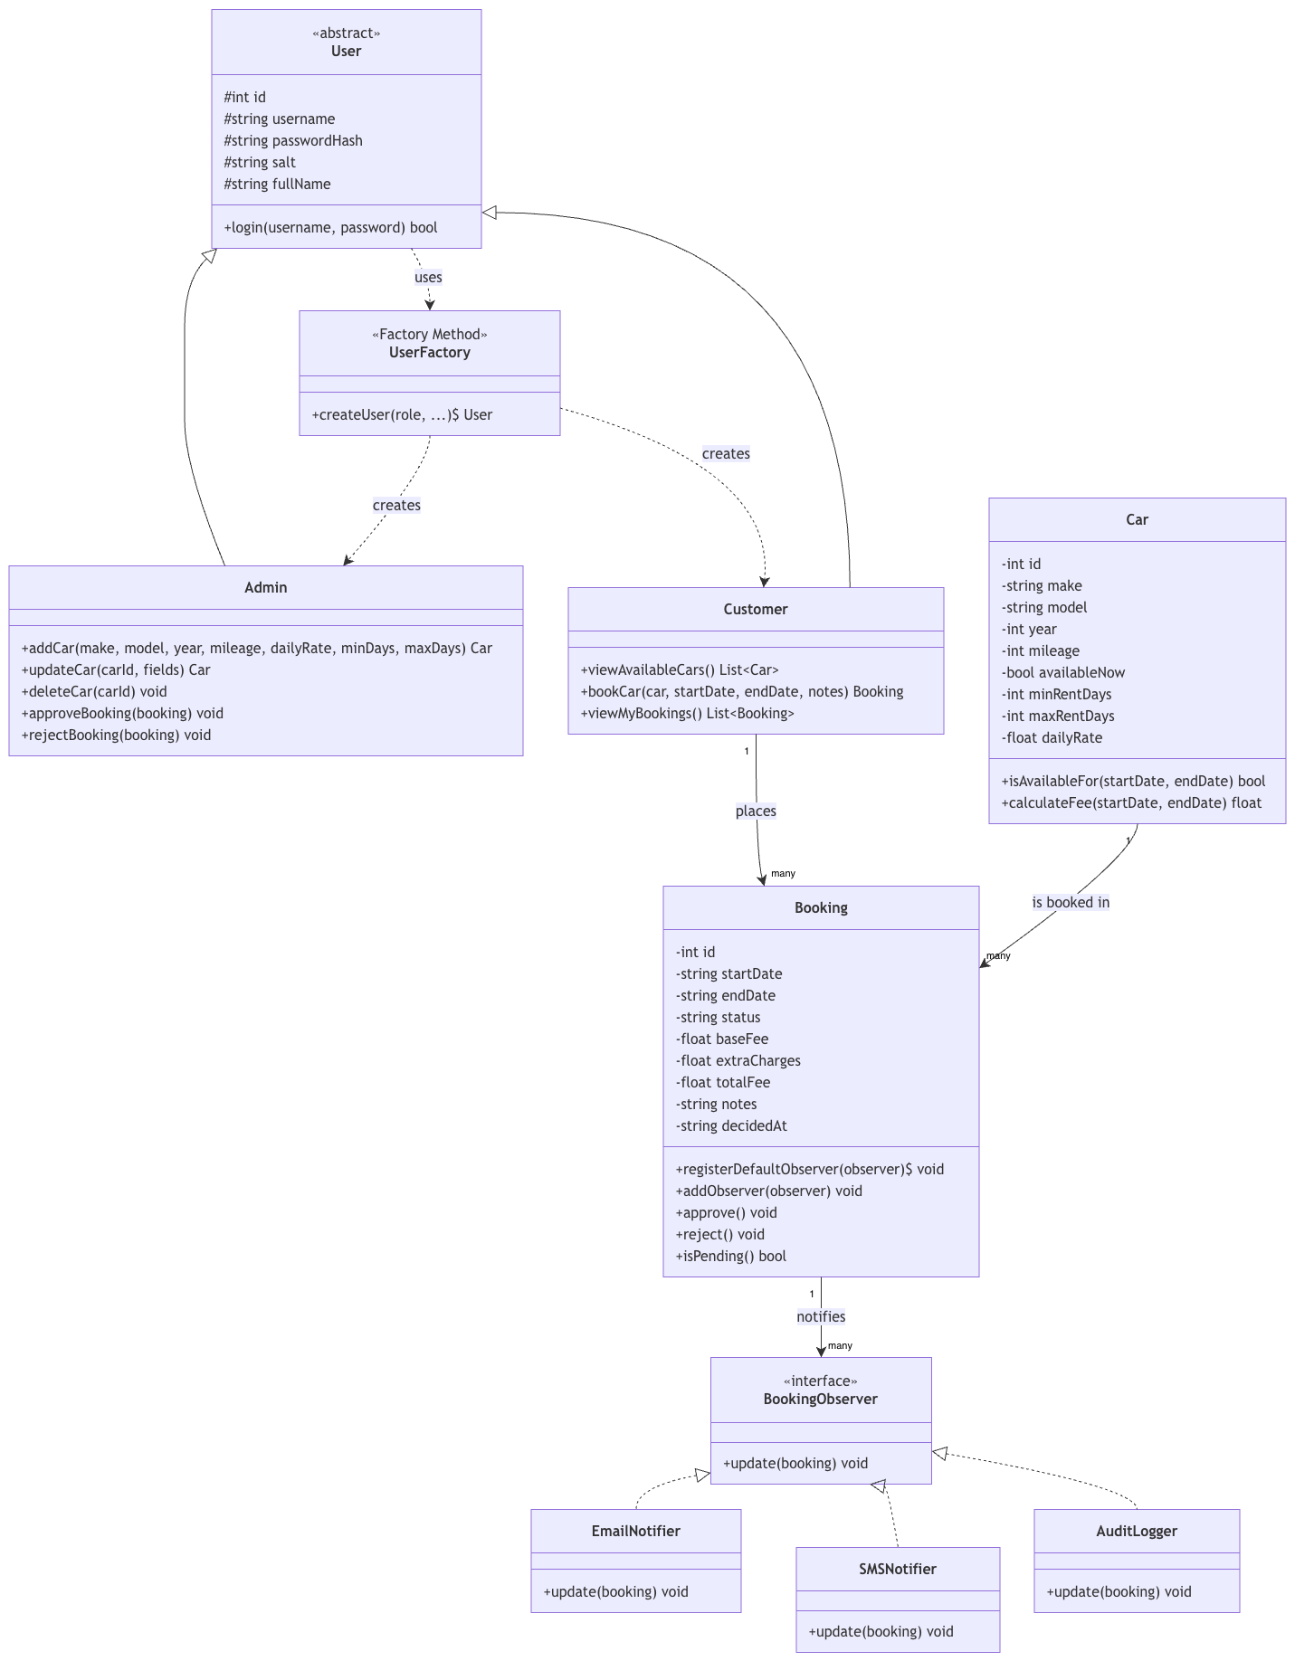
Figure 9 - Class Diagram
Core domain classes
Class | Responsibility
User (abstract) | Shared identity fields (id, username, passwordHash, salt, fullName). Implemented using Python's abc module (Python Software Foundation) so that User itself cannot be instantiated directly — only Admin or Customer objects exist at runtime.
Admin | Fleet management (addCar/updateCar/deleteCar) and booking decisions (approveBooking/rejectBooking).
Customer | Browsing (viewAvailableCars), booking (bookCar), and tracking (viewMyBookings).
Car | Vehicle data plus the behaviour that depends on it: isAvailableFor() checks for date overlaps, calculateFee() validates the requested date range (including rejecting a start date in the past) and computes the rental cost including a mileage surcharge.
Booking | Rental request data and its lifecycle: approve() and reject() are used to change the state, and isPending() is used to report the state. Additionally, it acts as the subject in the Observer pattern (Section 4.3).

- User <|-- Admin and User <|-- Customer: inheritance. Each role's permitted actions exist only as methods on the matching subclass, so calling an Admin-only method on a Customer object fails at the language level (AttributeError) rather than relying on an if-statement checking a role flag.
- The relationship between Customer and Booking is one to many, and the relationship between Car and Booking is one to many: a customer may place many bookings, and a car may appear in many bookings over time.

Sequence Diagrams
The sequence diagram illustrates the two most important interaction flows in the system over time: user authentication, and the creation and approval of reservations. Solid arrows represent synchronous calls, while dashed arrows indicate the corresponding return values. Activation bars (shaded rectangles on the lifelines) mark the periods during which objects are actively executing.

Registration and Login
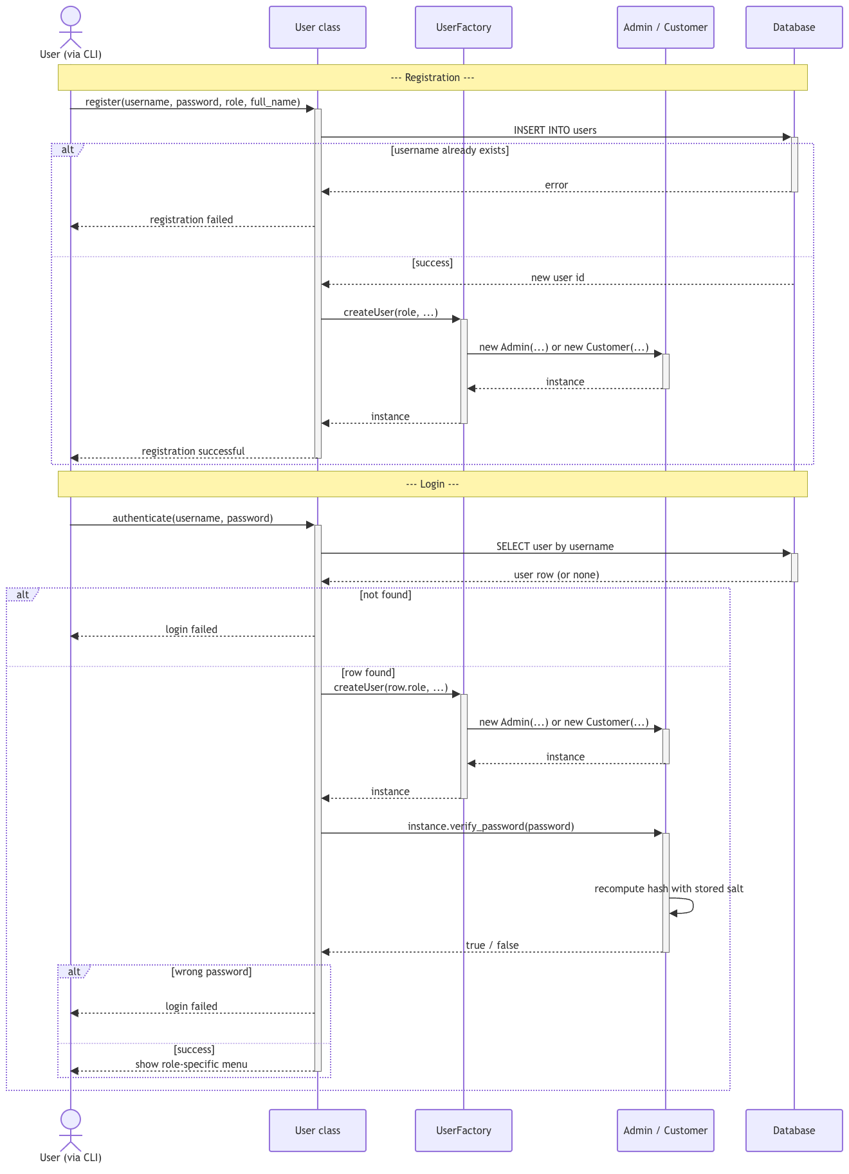
Figure 10 - Sequence Diagram: Registration and Login
The CLI layer is omitted here to focus the diagram on domain logic. The "User class" lifeline represents the User.register() and User.authenticate() methods; both explicitly call UserFactory.createUser() to instantiate the appropriate Admin or Customer object. This illustrates the runtime execution of the Factory Method pattern described in Section 4.2.
- Registration: The user submits details; the system validates them and inserts a new record. An alt (conditional) block shows two outcomes: the username is already taken, or the insertion succeeds (at which point UserFactory instantiates the correct subclass and confirms successful registration).
- Login: The system searches for the username; upon a match, it uses UserFactory to instantiate the correct subclass and instructs that instance to verify the input password against its stored hash. A nested alt block shows the final outcomes: invalid credentials, or successful login followed by directing the user to the menu corresponding to their role.

Booking Creation and Admin Approval
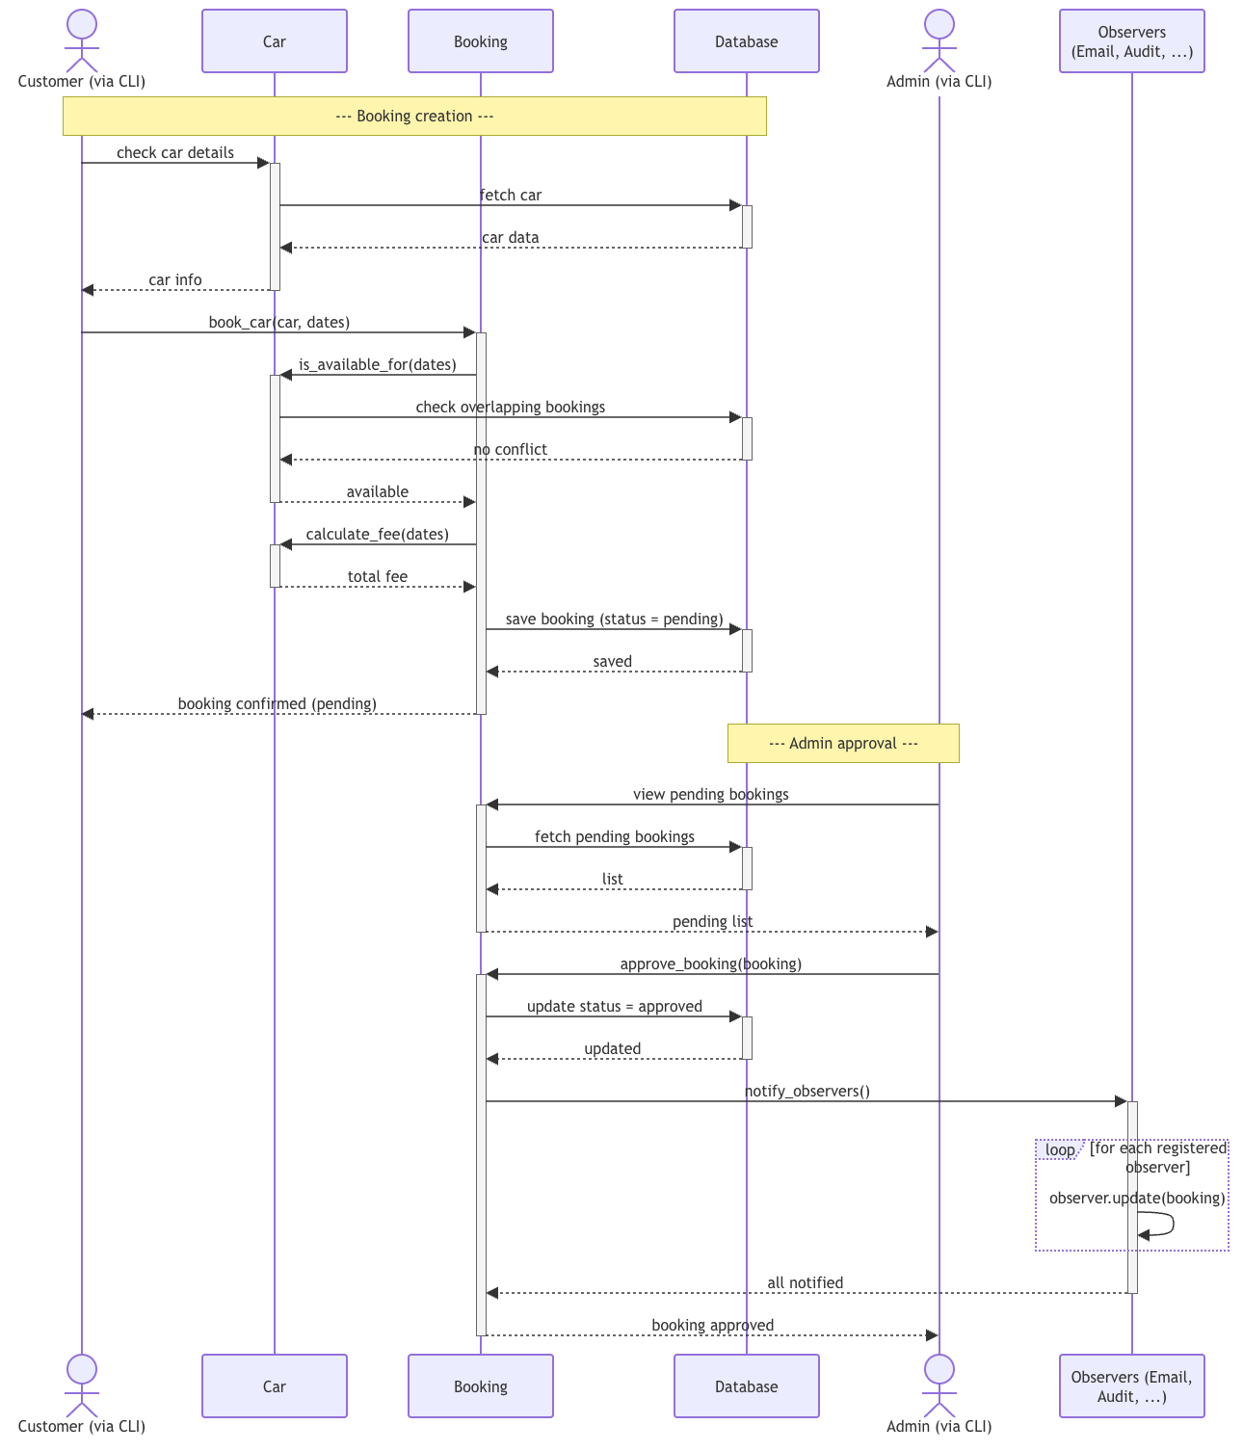
Figure 11 - Sequence Diagram: Booking Creation and Admin Approval
The diagram illustrates the complete lifecycle of a booking, divided into two phases by an annotation bar:
- Booking Creation: the customer inspects a car's details, then requests a booking for specific dates; Booking checks availability and calculates the fee — which includes validating that the start date is not in the past — before persisting the new booking with status = pending.
- Administrator Approval: An administrator accesses the pending list and approves the booking; the system updates the booking status and then calls notify_observers(). The loop fragment in the diagram depicts the process of calling update() for each registered observer (e.g., Email, Audit)—demonstrating the runtime execution of the Observer pattern described in Section 4.3.
Note: The final "Booking Approved" message is returned to the administrator, as it is the return value of the approve_booking() method invoked within the administrator's session. In contrast, the actual customer-facing notification is sent as a separate message via the Observers lifeline within the aforementioned loop; the diagram distinguishes between the two to avoid creating the false impression that the customer is synchronously waiting for the method call to complete.

Object-Oriented Principles and Design Patterns
This section discusses how the codebase applies the SOLID principles (Martin, 2003), and documents the two design patterns actually implemented in the system, both catalogued by Gamma, Helm, Johnson, and Vlissides (1994): Factory Method and Observer.

SOLID Principles in the Codebase
The five SOLID principles (Martin, 2003) are examined below in the context of this codebase.
Single Responsibility Principle — each class has exactly one reason to change. User/Admin/Customer own identity and permissions; Car owns vehicle data and availability/fee logic; Booking owns the rental lifecycle; UserFactory owns object construction; the persistence layer (db.py) owns database access; main.py owns user interaction. No class mixes these concerns.
Open/Closed Principle — classes are open for extension but closed for modification. BookingObserver lets new notification channels be added by writing a new class, without editing Booking or Admin. UserFactory lets a new role be added by extending one method, without changing every place a User is constructed.
Liskov Substitution Principle — Admin and Customer can be used anywhere the abstract User type is expected (for example, code that only needs common fields like username or full_name) without altering correctness — neither subclass weakens a guarantee the base class makes.
Interface Segregation Principle — BookingObserver exposes exactly one method, update(booking). A concrete notifier is never forced to implement functionality it does not need.
Dependency Inversion Principle — Booking depends on the abstract BookingObserver interface, not on concrete classes like EmailNotifier. The high-level policy ('notify interested parties when status changes') is decoupled from the low-level detail of how any particular channel delivers that notification.

Factory Method Pattern
Factory Method is one of the creational patterns catalogued by Gamma, Helm, Johnson, and Vlissides (1994).
Problem: creating a User requires deciding, based on a role string, whether to construct an Admin or a Customer. Scattering that decision across every place a user is created or logged in would duplicate logic and make it easy to forget a case when a new role is added later.
Solution: a dedicated UserFactory class centralises this decision behind a single static method.
- UserFactory.createUser(role, ...) constructs and returns an Admin or a Customer based on the role argument, and raises an error for any unrecognised role.
- User.register() and User.authenticate() both delegate to UserFactory instead of branching on role themselves.
Benefit: adding a new role in the future (e.g. a 'fleet_manager') means changing UserFactory in one place; every caller that already goes through the factory picks up the new role automatically.

Observer Pattern
Observer is one of the behavioural patterns catalogued by Gamma, Helm, Johnson, and Vlissides (1994).
Problem: when a booking's status changes (approved/rejected), one or more things need to happen in response — notifying the customer by email, by SMS, and/or recording an audit trail entry. Hard-coding all of these inside Booking or Admin would tightly couple the core rental logic to every notification channel.
Solution: Booking is the subject in an Observer pattern. Any class implementing the BookingObserver interface (a single update(booking) method) can be registered as an observer, either globally (Booking.registerDefaultObserver()) or per-instance (booking.addObserver()). When a booking's status changes, Booking._decide() calls _notify_observers(), which calls update() on every registered observer without needing to know what each one does.
- BookingObserver «interface» — the contract all notification channels implement.
- EmailNotifier, SMSNotifier, AuditLogger — concrete observers currently implemented (EmailNotifier and AuditLogger are wired up at application start-up in main.py; SMSNotifier is implemented and ready to be registered the same way).
Benefit: this pattern is also the architectural basis for the innovative feature proposed in Section 5 — proactive, push-based booking notifications. Because notification channels are decoupled behind the BookingObserver interface, replacing the current simulated notifications with real integrations requires only a new observer implementation, with no change to Booking, Admin, or Customer.

Layered Architecture
As shown in Figure 1, the codebase is organised into three layers — presentation (main.py), domain (models.py), and persistence (db.py) — with dependencies flowing one way (presentation depends on domain, domain depends on persistence, never the reverse).
In its current form, domain classes call db.get_connection() directly rather than going through a dedicated Repository class per entity (e.g. a CarRepository or BookingRepository). This keeps the codebase small and easy to follow for a system of this scope, at the cost of some duplication of query logic across Car and Booking. Introducing per-entity repository classes is identified as a concrete next step in the future roadmap (Section 6.4), and would let domain classes depend only on an abstract repository interface, further isolating them from SQLite-specific details.
A Singleton was deliberately not used for the database connection: sqlite3 connections in this system are short-lived (opened, used, and closed within a single with block per operation), which is simpler and safer for a single-user CLI application than sharing one long-lived global connection. A Singleton would only be worth the added global state if the system needed to coordinate a shared, expensive-to-create resource across many concurrent operations. Password hashing uses the standard library's hashlib.pbkdf2_hmac implementation (Python Software Foundation), and all persistence goes through Python's built-in sqlite3 module against a standard SQLite database file (SQLite Consortium).

Innovative Solution
This section addresses Task 2 by describing an innovative feature built on top of the baseline requirements from Section 2.

Proposed Innovation
This proposed innovation is a proactive booking notification system based on a "push" mechanism, designed directly around the Observer pattern described in Section 4.3. Instead of requiring customers to repeatedly log in to check the status of their bookings, the system automatically notifies relevant parties the moment a status change occurs.
By encapsulating notification channels behind an abstract `BookingObserver` interface, the system supports the simultaneous registration of multiple channels, such as email, SMS, and audit logs, without requiring modifications to the core booking or approval logic. Furthermore, the system can be easily extended to integrate with specific services (e.g., SMTP mail servers, SMS gateways like Twilio, or mobile push notification services) simply by adding a new observer class for each channel.

Industry Problem Addressed
The context of this task highlights a core issue: traditional manual, paper-based rental processes are both time-consuming and error-prone. Even with document digitization, customers and staff still spend significant time verifying booking statuses—whether by making calls, refreshing system pages, or waiting for callbacks. This represents a "pull" interaction model, where customers must repeatedly query the system for the latest updates.
In contrast, a notification system built on the "Observer" pattern transforms this into a "push" model: the system automatically notifies the customer as soon as an administrator makes a decision. This not only eliminates the need for customers to actively check their status but also reduces the manual workload for administrators regarding follow-up tasks.

Competitive Advantage
- Faster perceived response times: Customers are notified of booking outcomes moments after an administrator makes a decision, eliminating the need to wait until their next system login to check the status.
- Reduced operational overhead: Staff no longer need to manually make calls or send emails to communicate decisions; the system handles this process automatically and consistently.
- Scalability as a key advantage: The decoupled design of BookingObserver allows additional communication channels, such as in-app push notifications, WhatsApp, or notification feeds in partner travel applications, to be incorporated with minimal impact on the existing booking and approval logic. This extensibility demonstrates how the design patterns discussed in Section 4 contribute to maintainability and modularity, while also supporting the system’s ability to accommodate evolving functional requirements.

Coding Standards
Alongside the functional and architectural criteria discussed above, the codebase follows standard Python coding conventions (Python Software Foundation, PEP 8) across five dimensions:
Modularity and Encapsulation — the three-layer structure in Section 3.1 keeps presentation, domain, and persistence concerns in separate files; within the domain layer, each class exposes only the methods callers need and keeps internal fields (e.g. User's password hash and salt) marked as protected/private by convention.
Performance considerations — date-range and status filtering happen in SQL WHERE clauses (e.g. the overlap check in Car.is_available_for()) rather than by pulling every row into Python and filtering there; the PBKDF2 iteration count for password hashing is chosen to balance login latency against resistance to brute-force attacks.
Commenting and Documentation — every module opens with a docstring explaining its role and any non-obvious design decisions (for example, why User.authenticate() is a classmethod rather than an instance method), and inline comments mark the exact lines where each design pattern is invoked.
Indentation and Formatting — consistent 4-space indentation and line structure throughout, following PEP 8 (Python Software Foundation).
Naming Conventions — snake_case for functions, methods, and variables; PascalCase for classes (Admin, UserFactory, BookingObserver); and module-level constants in upper case (e.g. HIGH_MILEAGE_THRESHOLD), all per PEP 8 (Python Software Foundation).

Software Evolution
This section addresses Task 3 by outlining how the system would be maintained, versioned, and kept backward compatible as it evolves beyond this assignment submission.

Maintenance Strategy
- Issue tracking: bugs and enhancement requests are logged in an issue tracker (e.g. GitHub Issues), each tagged with a severity (critical / major / minor) and a category (User Management, Car Management, Rental Booking, Rental Management) matching the assignment's own requirement groupings.
- Regression testing before every change: the project already includes smoke tests exercising registration, login, car CRUD, booking creation, overlap detection, fee calculation, and the approval workflow. These are run before merging any fix or feature, so a change that repairs one workflow cannot silently break another. For example, when a missing validation rule was found that allowed a booking to be created with a start date in the past, the fix (a single check added to Car.calculate_fee()) was verified both in isolation and against the full existing regression suite before being accepted, confirming that overlap detection, minimum/maximum rental period enforcement, and the mileage surcharge all still behaved correctly.
- Code review: every change is reviewed against the layering described in Section 4.4 before merging, a proposed change that mixes persistence logic into models.py or business logic into main.py is a review flag, not just a style preference.
- Audit trail as a maintenance tool: the AuditLogger observer from Section 4.3 already records every booking status change with a timestamp; this same mechanism can be extended to log other state-changing operations, giving maintainers a record to diagnose reported issues after the fact.

Versioning Strategy
- Semantic Versioning (MAJOR.MINOR.PATCH) for the application itself: PATCH for bug fixes with no behaviour change, MINOR for backward-compatible additions (e.g. a new car field, a new observer channel), MAJOR for any breaking change to stored data or public method signatures.
- A simple branching model: a stable main branch that always reflects the current release, short-lived feature branches for new work, merged in via reviewed pull requests, and a changelog file that records what changed in each version.
- Explicit schema versioning: the current schema is created with CREATE TABLE IF NOT EXISTS, which works for a first release but does not on its own track which schema version a given database file is at. A recommended addition is a small schema_version table (or a PRAGMA user_version call) so that future releases can detect an older database file and apply migrations automatically instead of assuming the schema is already current.

Backward Compatibility Strategy
- Additive schema changes preferred: new columns are added as nullable or with a default value (following the same pattern already used for full_name and decided_at in the current schema) rather than renaming or removing existing columns, so older application code, or a database file created by an earlier version, continues to work.
- Deprecation before removal: if a method's signature must change, the old signature is kept as a thin wrapper around the new one for at least one minor version, with a deprecation warning, before being removed in a subsequent major version.
- Design patterns as a compatibility mechanism: because new roles are added by extending UserFactory (Section 4.2) and new notification channels by adding a new BookingObserver implementation (Section 4.3), both of these common types of future change can be made without touching, and therefore without risking, the existing, already-tested Admin, Customer, or Booking classes.
- If the system later exposes a network API (see roadmap below), API endpoints would be versioned in the URL path (e.g. /v1/, /v2/) so existing client integrations keep working unchanged while a new version is introduced alongside them.

Future Roadmap

Short term
- Replace the simulated EmailNotifier/SMSNotifier with real integrations (an SMTP provider, an SMS gateway such as Twilio), a direct extension of the Observer pattern already in place.
- Introduce the schema_version mechanism described in Section 6.2 before the first external release.

Medium term
- Introduce per-entity repository classes (CarRepository, BookingRepository) as discussed in Section 4.4, so domain classes no longer call db.get_connection() directly. This reduces duplicated query logic and makes it easier to swap the storage engine later.
- Add a web or mobile front end that calls the same domain layer (models.py) the CLI uses today, because business logic lives entirely in the domain layer, this front end change would not require touching Admin, Customer, Car, or Booking.

Long term
- Support multiple rental branches/locations and fleet-wide reporting for Admin users.
- Add payment processing at booking confirmation time, and a loyalty/repeat-customer feature building on the existing Customer class.
Across every stage of this roadmap, the underlying design principle stays the same: sound software engineering practice, clear layering, narrow interfaces, and additive rather than destructive change — is what keeps each of these additions low-risk and independent of one another, which is the foundation for the system's long-term success.

Conclusion
This report presents an object-oriented design for a car rental system that meets the project's functional requirements. It employs the Factory Method and Observer design patterns to maintain the codebase's modularity and extensibility, and introduces a proactive notification feature as an innovative solution to the practical limitations of manual and traditional rental processes. The strategies regarding maintenance, version control, and backward compatibility outlined in Section 6 aim to ensure that the established architecture serves not merely as a one-off project submission, but as a foundation for a system capable of sustained growth and continuous evolution.

References
Gamma, E., Helm, R., Johnson, R., & Vlissides, J. (1994). Design patterns: Elements of reusable object-oriented software. Addison-Wesley.
Martin, R. C. (2003). Agile software development: Principles, patterns, and practices. Prentice Hall.
Python Software Foundation. (2001). PEP 8 – Style Guide for Python code. https://peps.python.org/pep-0008/
Python Software Foundation. (n.d.). abc — Abstract base classes. Python 3 documentation. https://docs.python.org/3/library/abc.html
Python Software Foundation. (n.d.). hashlib — Secure hashes and message digests. Python 3 documentation. https://docs.python.org/3/library/hashlib.html
Python Software Foundation. (n.d.). sqlite3 — DB-API 2.0 interface for SQLite databases. Python 3 documentation. https://docs.python.org/3/library/sqlite3.html
SQLite. (n.d.). SQLite documentation. https://www.sqlite.org/docs.html

